Voice of share for Chen Shih-Chung陳時中聲量分析

Take a look at the demonstration website.

In this app, we display the voice of share for Chen Shih-Chung陳時中.

Let’s get started!

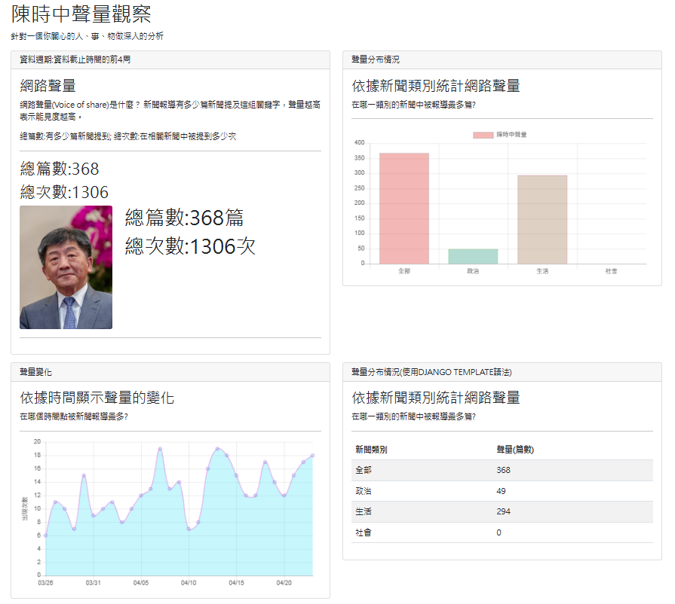

Step 0: Create a project by duplicating previous project

We will continue from our previous project.

I suggest you rename your project folder with a meaningful name such as:

“website_news_analysis_app_scchen”

Step1: Open the project with your favorite Editor

Open our project using VS Code.

Step 2: Create “app_scchen”

Step 2: Create a new APP named “app_scchen” in your website root.

python manage.py startapp app_scchen

Step3: Copy data file to the dataset folder

We will use the preprocessed data file, so copy it into the dataset folder.

We have done this in our previous app.

Step 4: settings.py

|  |  |
| --- | --- |
| |  | | --- | | ALLOWED_HOSTS = ['*']  INSTALLED_APPS = [  …..  ' app_top_keyword',  ' app_top_person',  'app_top_ner_analysis',  'app_user_keyword',  'app_scchen',  ]  TEMPLATES = [  {  'BACKEND': 'django.template.backends.django.DjangoTemplates',  'DIRS': [os.path.join(BASE_DIR, 'templates')],  'APP_DIRS': True,  'OPTIONS': …..  ……  ……  },  ] | |

Step 5: website_configs/urls.py

website_configs/urls.py

|  |  |
| --- | --- |
| |  | | --- | | from django.contrib import admin  from django.urls import path  from django.urls import include  from django.views.generic import TemplateView  urlpatterns = [  # top keywords  path('topword/', include('app_top_keyword.urls')),  # top persons  path('topperson/', include('app_top_person.urls')),  # top name entity keyword  path('topner/', include('app_top_ner.urls')),  # app shih chung chen  path('scchen/', include('app_scchen.urls')),  ] | |

Step 6: app_scchen/urls.py

In folder app_scchen, create a Python file named “urls.py”.

app_scchen/urls.py

|  |  |
| --- | --- |
| |  | | --- | | from django.urls import path  from . import views  # 使用app_name是讓各個APP的變數與方法名稱有區隔  # 若名稱不衝突，不使用app_name也可以  # app_name是一種namespace的概念  # 整合多個可獨立運作的APP成為一個大型專案必備知識  # 在template中如何使用?  # <a class="nav-link" href="{% url 'app_top_person:home' %}">熱門人物</a>  app_name="app_scchen"  urlpatterns = [  # top (popular) persons  path('', views.home, name='home'),  ] | |

Step 7: views.py

views.py

|  |
| --- |
| from django.http import JsonResponse  from django.shortcuts import render  import pandas as pd  def load_data_scchen():  # Read data from csv file  df_data = pd.read_csv('app_scchen/dataset/chen_shih_chung_data.csv',sep=',')  global response  response = dict(list(df_data.values))  # get the frequency of each category  response["categroy_frequency"] = list(zip(eval(response["category"]), eval(response["freqByCate"])))  del df_data  # load data  load_data_scchen()  # get the frequency of each category  # 讓前端用表格方式顯示 (使用Django Template語法)  '''  <tbody>  {% for category, freq in categroy_frequency %}  <tr>  <td>{{ category }}</td>  <td>{{ freq }}</td>  </tr>  {% endfor %}  </tbody>  '''  # print(response)  def home(request):  return render(request,'app_scchen/home.html', response)  print('app_scchen was loaded!') |

Step 8: home.html

How does JavaScript or html read data from Django server

(1)使用Ajax與後端要資料

(2)讀取Django後端送過來的資料 變數名稱寫在兩個大括弧中間即可

For html:

|  |
| --- |
| <!-- Leaderboard Content -->  <h2>總篇數:{{num_occurrence|safe}}</h2>  <h2>總次數:{{num_frequency|safe}}</h2> |

加上 safe 是不讓Django做一些特殊符號的代號轉換(XSS安全機制)，否則我們拿到的資料顯示會有錯誤

For JavaScript:

|  |
| --- |
| const freqByCate = {{freqByCate|safe}}; // for bar chart  const news_category = {{category|safe}}; // for bar chart  const freqByDate = {{ freqByDate|safe }}; // for line chart  const num_occurrence = {{num_occurrence|safe}}; // for share of voice  const num_frequency = {{num_frequency|safe}}; // for share of voice |

In the app folder, create a HTML file named “home.html”

app_scchen/templates/app_scchen/home.html

home.html

|  |
| --- |
| {% extends 'base.html' %} {% block title %} 陳時中聲量觀察 {% endblock %}  {%block content %}  <div class="col-lg-12">  <h1>陳時中聲量觀察</h1>  <p>針對一個你關心的人、事、物做深入的分析</p>  </div>  <!-- 顯示區塊-->  <div class="col-lg-6 mb-3">  <div class="card">  <div class="card-header">  <h3 class="h6 text-uppercase mb-0">資料週期:資料截止時間的前4周</h3>  </div>  <div class="card-body">  <div class="row">  <!-- Leaderboard Container -->  <div class="container-fluid">  <!-- Leaderboard Heading -->  <h3>網路聲量</h3>  <p>  網路聲量(Voice of share)是什麼？  新聞報導有多少篇新聞提及這組關鍵字，聲量越高表示能見度越高。  </p>  <p>總篇數:有多少篇新聞提到; 總次數:在相關新聞中被提到多少次</p>  <hr />  <!-- Leaderboard Content -->  <h2>總篇數:{{num_occurrence|safe}}</h2>  <h2>總次數:{{num_frequency|safe}}</h2>  <div id="share_of_voice"></div>  </div>  <!-- /.container -->  </div>  </div>  </div>  </div>  <!-- 區塊結束-->  <!-- 繪圖區塊-->  <div class="col-lg-6 mb-3">  <div class="card">  <div class="card-header">  <h3 class="h6 text-uppercase mb-0">聲量分布情況</h3>  </div>  <div class="card-body">  <!-- description -->  <h3>依據新聞類別統計網路聲量</h3>  <p>在哪一類別的新聞中被報導最多篇?</p>  <hr />  <canvas id="bar_chart"></canvas>  </div>  </div>  </div>  <!-- 區塊結束-->  <!-- 顯示區塊-->  <div class="col-lg-6 mb-3">  <div class="card">  <div class="card-header">  <h3 class="h6 text-uppercase mb-0">聲量變化</h3>  </div>  <div class="card-body">  <!-- description -->  <h3>依據時間顯示聲量的變化</h3>  <p>在哪個時間點被新聞報導最多?</p>  <hr />  <canvas id="line_chart"></canvas>  </div>  </div>  </div>  <!-- 區塊結束-->  <!-- 使用Django Template語法 -->  <div class="col-lg-6 mb-3">  <div class="card">  <div class="card-header">  <h3 class="h6 text-uppercase mb-0">聲量分布情況(使用Django Template語法)</h3>  </div>  <div class="card-body">  <!-- description -->  <h3>依據新聞類別統計網路聲量</h3>  <p>在哪一類別的新聞中被報導最多篇?</p>  <p>使用Django Template語法:非常方便，值得學習。</p>  <hr />  <div class="table-responsive">  <table class="table table-striped">  <thead>  <tr>  <th>新聞類別</th>  <th>聲量(篇數)</th>  </tr>  </thead>  <tbody>  {% for category, freq in categroy_frequency %}  <tr>  <td>{{ category }}</td>  <td>{{ freq }}</td>  </tr>  {% endfor %}  </tbody>  </table>  </div>  </div>  </div>  </div>  <!-- 區塊結束-->  {% endblock %} {% block extra_js %}  <!-- jQuery指令用到的js-->  <!-- 繪製line chart會用到，必須在chartjs之前先載入 -->  <script src="https://cdnjs.cloudflare.com/ajax/libs/moment.js/2.13.0/moment.min.js"></script>  <!-- chartjs圖js-->  <script src="https://cdnjs.cloudflare.com/ajax/libs/Chart.js/2.7.3/Chart.min.js"></script>  <!-- 程式碼區 -->  <script>  // How does JavaScript read data from Django server  // (1)使用Ajax與後端要資料  // (2)讀取Django後端送過來的資料 變數名稱寫在兩個大括弧中間即可  // 加上 safe 是不讓Django做一些特殊符號的代號轉換(XSS安全機制)，否則我們拿到的資料顯示會有錯誤  const freqByCate = {{freqByCate|safe}}; // for bar chart  const news_category = {{category|safe}}; // for bar chart  const freqByDate = {{ freqByDate|safe }}; // for line chart  const num_occurrence = {{num_occurrence|safe}}; // for share of voice  const num_frequency = {{num_frequency|safe}}; // for share of voice  const photo ="https://upload.wikimedia.org/wikipedia/commons/c/c0/%E8%A1%9B%E7%94%9F%E7%A6%8F%E5%88%A9%E9%83%A8%E9%83%A8%E9%95%B7%E9%99%B3%E6%99%82%E4%B8%AD.jpg";  //display data and show chart  displayShareOfVoice();  drawBarChart();  showLineChart();  // *****************  // Function for displaying the share of voice  function displayShareOfVoice() {  // define a html block 一個區塊  let html_snippet = `  <div class="row">  <div class="col-md-4">  <a href="#">  <img class="img-fluid rounded mb-3 mb-md-0" src=${photo} alt="陳時中照片">  </a>  </div>  <div class="col-md-8">  <h1>總篇數:${num_occurrence}篇</h1>  <h1>總次數:${num_frequency}次</h1>  </div>  </div>  <hr>`;  const new_div = document.createElement("div");  new_div.innerHTML += html_snippet;  document.getElementById("share_of_voice").appendChild(new_div);  }  // *****************  // Chart.defaults.global.defaultFontSize = 15;  // 繪製長條圖的函數  function drawBarChart() {  const freq_values = freqByCate;  const news_categories = news_category;  //console.log(freq_values);  // data for chart  let data = {  labels: news_categories, //x axis 橫坐標軸  datasets: [  {  label: "陳時中聲量",//chart標題  data: freq_values, //縱軸數值  backgroundColor: randomColors(freq_values.length),  borderColor: randomColors(freq_values.length),  borderWidth: 1,  },  ],  };  // options for chart, y axis value begins at zero  let options = {  scales: {  yAxes: [  {  ticks: {  beginAtZero: true, //從0開始  responsive: true //符合響應式  },  },  ],  },  };  // get chart id from html  const barChartElem = document.getElementById("bar_chart");  // new a bar chart  new Chart(barChartElem, {  type: "bar",  data: data,  options: options,  });  }  // *****************  // Line chart  function showLineChart() {  const lineChartElem = document  .getElementById("line_chart")  .getContext("2d");  const freq_values = freqByDate;  const myoptions = {  type: "line",  data: {  datasets: [  {  label: "s2",  borderColor: randomColors(1),  backgroundColor: randomColors(1),  borderWidth: 2,  data: freq_values,  },  ],  },  options: {  legend: {  display: false,  },  scales: {  xAxes: [  {  type: "time",  time: {  unit: "day",  displayFormats: {  //day: 'DD-MM-YYYY'  day: "MM/DD",  },  },  },  ],  yAxes: [  {  ticks: {  beginAtZero: true, //從0開始  responsive: true, //符合響應式  },  display: true,  scaleLabel: {  display: true,  labelString: "出現次數",  },  },  ],  },  },  };  // 檢查line_chart變數是否存在，如果存在，表示已經有之前畫的圖，必須要先清除之後，再畫新的圖。否則會有新舊圖重疊現象  //用以下這種方式檢查與清除舊圖。window指的是這個頁面，這個頁面有很多變數存在，檢查line_chart是否存在，若有存在，必須要先清除之後，再畫新的圖。否則會有新舊圖重疊現象  if (window.time_line_chart) {  time_line_chart.destroy();  }  // 畫一張新圖(產生一個圖物件變數名稱為line_chart)  // 必須全域變數--注意:前面不要有let, var, const等修飾詞  // 理由: 我們要讓它存在於網頁全域變數，  // 這樣我們才方便判斷是否有前一次的圖，如果存在有，要刪除之，否則，很多張圖會疊在一起  time_line_chart = new Chart(lineChartElem, myoptions);  }  // randomize color  function randomColors(length) {  var pool = [];  for (let i = 0; i < length; i++) {  pool.push(dynamicColors());  }  return pool;  }  function dynamicColors() {  var r = Math.floor(Math.random() * 255);  var g = Math.floor(Math.random() * 255);  var b = Math.floor(Math.random() * 255);  return "rgba(" + r + "," + g + "," + b + ", 0.3)";  }  </script>  {% endblock %} |

Step 9: base.html

a class="nav-link" href="{% url 'app_scchen:home' %}" style="color: green">時中聲量我最大</a>

Step 10: Run server

python manage.py runserver 8000

What does your web page look like?

Step 11: Django Template

顯示新聞類別頻率Table範例

|  |
| --- |
| <!-- 使用Django Template語法 -->  <div class="col-lg-6 mb-3">  <div class="card">  <div class="card-header">  <h3 class="h6 text-uppercase mb-0">聲量分布情況(使用Django Template語法)</h3>  </div>  <div class="card-body">  <!-- description -->  <h3>依據新聞類別統計網路聲量</h3>  <p>在哪一類別的新聞中被報導最多篇?</p>  <p>使用Django Template語法:非常方便，值得學習。</p>  <hr />  <div class="table-responsive">  <table class="table table-striped">  <thead>  <tr>  <th>新聞類別</th>  <th>聲量(篇數)</th>  </tr>  </thead>  <tbody>  {% for category, freq in categroy_frequency %}  <tr>  <td>{{ category }}</td>  <td>{{ freq }}</td>  </tr>  {% endfor %}  </tbody>  </table>  </div>  </div>  </div>  </div>  <!-- 區塊結束--> |

請AI解說Django Template

Django Template 是 Django 框架中用來建立 **前端 HTML 頁面** 的一套模板語言（Template Language）。它可以讓你在 HTML 裡使用一些簡單的語法，來動態地顯示從後端傳來的資料。

### 🎯 主要特色

1. **簡單易學**：語法接近 HTML，並加上一些簡單的標記（tags）與變數（variables）。
2. **安全**：自動防止跨站腳本攻擊（XSS），不會直接輸出危險的 HTML。
3. **邏輯限制**：模板中只允許非常簡單的邏輯（例如 if、for），複雜邏輯應留在 view 或 model 處理。

### 🔧 基本語法

#### 1. 顯示變數

html

複製編輯

<p>Hello, {{ username }}!</p>

#### 2. if 判斷

html

複製編輯

{% if user.is_authenticated %}

<p>Welcome back!</p>

{% else %}

<p>Please log in.</p>

{% endif %}

#### 3. for 迴圈

html

複製編輯

<ul>

{% for item in items %}

<li>{{ item }}</li>

{% endfor %}

</ul>

#### 4. 匯入其他模板（模板繼承）

<!-- base.html -->

<html>

<body>

{% block content %}{% endblock %}

</body>

</html>

<!-- home.html -->

{% extends "base.html" %}

{% block content %}

<h1>This is the homepage</h1>

{% endblock %}

### 📁 使用範例

#### views.py

python

複製編輯

from django.shortcuts import render

def homepage(request):

return render(request, 'home.html', {'username': 'Alice'})

#### home.html

html

複製編輯

<h1>Hi {{ username }}</h1>

### 📌 常見用途

* 網頁動態顯示資料
* 表單處理
* 多語系支援（使用 {% trans %}）
* 分頁、排序顯示資料

如果你有特定的使用場景，例如表單、文章列表，或需要整合 Bootstrap，我可以幫你舉出完整範例。要不要我來做一個？